Connections

Lora | Arduino pro mini | ESP8266 NodeMCU
Reset | 9 | D3=GPIO00
DI00 | 2 | D8=GPIO15
NSS | 10 | D0=GPIO16
MOSI | 11 | D7=GPIO13
MISO | 12 | D6=GPIO12
SCK | 13 | D5=GPIO14

Voltage reg
Removing reduced sleep current from 70uA to 5uA.

Set fuses

upload ArduinoISP to uno

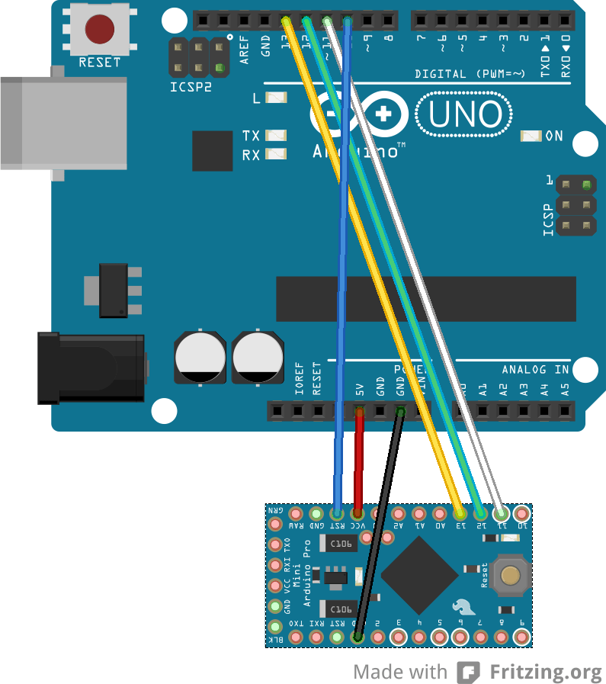
Connect as (https://forum.arduino.cc/index.php?topic=428245.0)

Check current avrdude -P /dev/ttyACM0 -b 19200 -c avrisp -p m328p -v
(http://heliosoph.mit-links.info/arduinoisp-reading-writing-fuses-atmega328p/)

Burn E:FE (1.8v BOD) avrdude -P /dev/ttyACM0 -b 19200 -c avrisp -p m328p -U efuse:w:0xfe:m

Check again (https://arduino.stackexchange.com/questions/24859/how-do-i-read-the-fuse-bits-from-within-my-sketch)

include <avr/boot.h>;

void setup()
{
Serial.begin(57600);
Serial.print("Low: 0x");
cli();
uint8_t lowBits = boot_lock_fuse_bits_get(GET_LOW_FUSE_BITS);
uint8_t highBits = boot_lock_fuse_bits_get(GET_HIGH_FUSE_BITS);
uint8_t extendedBits = boot_lock_fuse_bits_get(GET_EXTENDED_FUSE_BITS);
uint8_t lockBits = boot_lock_fuse_bits_get(GET_LOCK_BITS);
sei();

Serial.println(lowBits, HEX);
Serial.print("High: 0x");
Serial.println(highBits, HEX);
Serial.print("Ext: 0x");
Serial.println(extendedBits, HEX);
Serial.print("Lock: 0x");
Serial.println(lockBits, HEX);
}

void loop()
{
}

Future
#include "avr/power.h";
clock_prescale_set(clock_div_4); // This divides the clock by 4

PCB Requirements
reverse voltage protection?
ESD protection on cap sense
three capsense inputs
1 capsense output
1 trap
DS18b temp sensor (current protected)

Calibration tests
Closed intakes at 7/11 3pm

